Automating second antenna choice on one-antenna output systems ZS6KR

All radios and amplifiers have an RF output configuration where band filters are switched with relays to output RF drive to the final stage(s).

Commonly each band filter relay is activated with a positive going 12V DC via a manual band switch on older sets and indirectly via pushbuttons on modern sets.

The author wished to connect to another antenna on 40m and 80m without having to manually switch a coax switch.
This implies we need an external box with a changeover relay suitable to handle the required power. A 10A automotive relay proved to be a good choice. The solution is quite simple as shown in the diagram below:
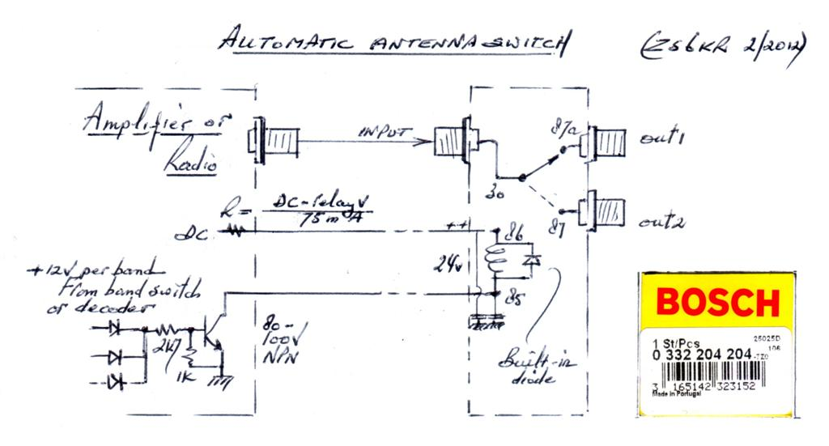
24V
You have to find the 12V switching lines to the relays in the band filter section and then OR gate whichever bands you wish to connect to the second antenna. The OR gating is simply done with diodes followed by the external relay driver transistor.

The choice of relay coil voltage depends on what is available in the radio or linear amplifier. The above example is for a 24V relay operated from 40V DC via a resistor R= (40V-24V)/(75mA coil current as established after its purchase).
Approximately 180-220 ohms 5W was fine for the author’s project but if your DC supply is 12V then purchase a 12V relay and no resistor is required. Possibly add a fuse in-line as this connection goes external.

Implementation is as shown in the following pictures:
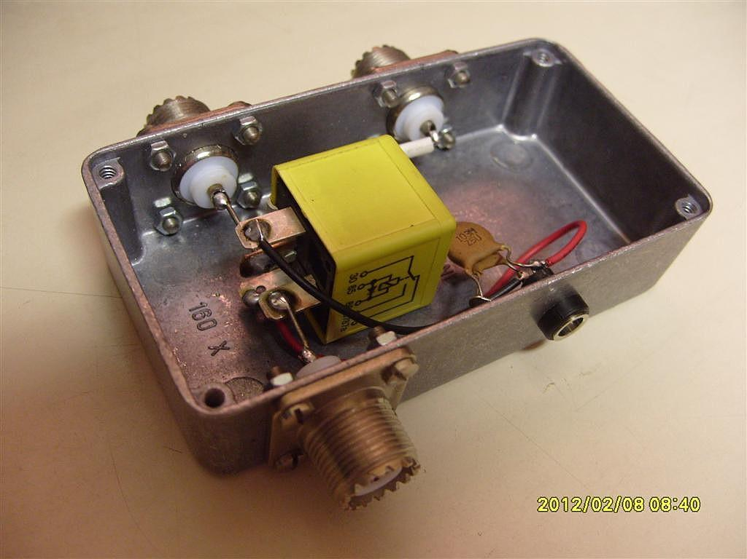
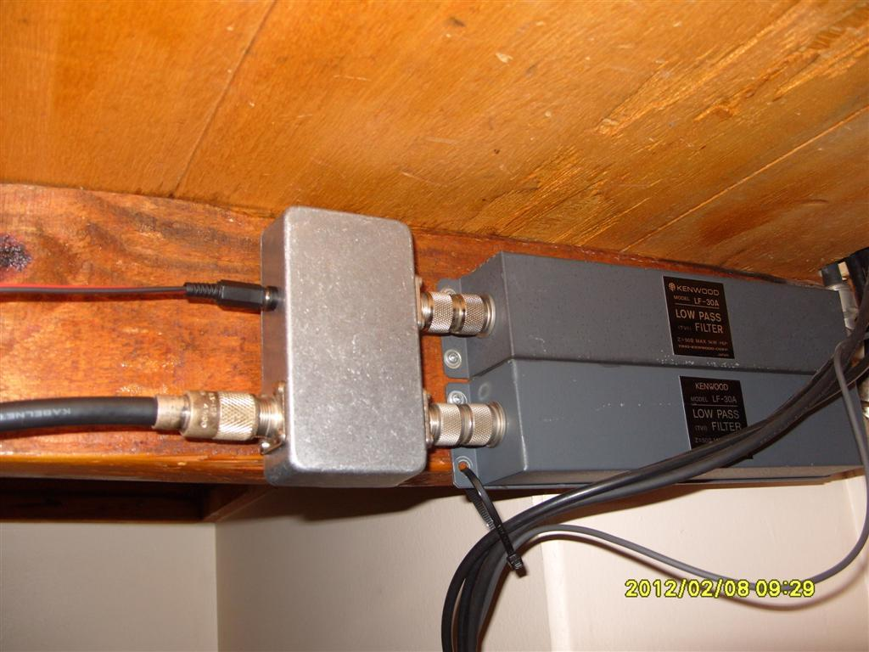

All parts fit in a Hammond 1590B box. The DC input is bypassed on both wires. The final installation was under my bench.

